OSPF LSA Types

Emma Matsuda

Advanced CCNP

**Purpose**

The purpose of this lab is for CCNPs to research the way routers use different LSA types in an OSPF network to exchange information and apply it to an actual physical network that was built from scratch. With this overall objective in mind, we were to create a network with 6 routers, with OSPF areas including Stubby, Totally Stubby, and Not-So-Stubby areas. Then, through Wireshark, we were to capture the different LSA Types that were assigned to us, Type 1, 2, 3, 4, 5, and 7.

**Background Info**

The OSPF, Open Shortest Path First, protocol is an IP Routing protocol, and is an Interior Gateway Protocol (IGP) for the Internet. Often used to distribute IP routing information throughout a single Autonomous System (AS) in an IP network, it separates the devices to sub-domains called areas. These areas lead to OSPF being two main categories, a single-area OSPF and a multi-area OSPF. In a single-area OSPF network, all the routers are assigned to the same area, and the traffic in the network is router between all the areas through a single area. This makes it easier for the network engineer to configure but not as efficient as the other option, multi-area OSPF. A multi-area OSPF network assigns each router to a specific area, and the traffic of the network is through a backbone area. This makes a multi-area OSPF network a bit of a burden to configure, but a lot more efficient than a single-area OSPF network. Multi-area networks also leave more space to utilize the components. The ability to simplify the configures OSPF areas using a concept called “stub areas” is the focus of this lab. Before further explaining about OSPF stubbiness, fully understanding the Link State Advertisements (LSAs) are important. LSAs are the message that get communicated via multicast to other routers in the same OSPF domain. They are usually sent from internal routers to the DR/BDR routers to announce its changes. The message that gets communicated include things like information about the topology/design of the network and routes that the network contains. Because there is such a wide variety of data packets that is being sent between the routers in an OSPF network, the LSAs are split into numerous types of them. In this lab, we focused on types 1, 2, 3, 4, 5, and 7. To explain further about the different types of LSAs, I have created the table below:

|  |  |  |
| --- | --- | --- |
| LSA Type | Name | Description |
| 1 | Router LSA | Point-to-point connection to another router. Each router within the area will flood a Type 1 within the OSPF area. To share its own information to other routers, sends information to its directly connected interfaces. OSPF routers use this type of LSA to describe its own interfaces but also carries information of its neighbors and adjacent routers in the same area. |
| 2 | Network LSA | Connection to transit network. Created for each multi-access network. Can find all routers connected to multi-access network, the DR, and prefix/subnet masks. Flooded between neighbors in the same OSPF network and does NOT cross the area boundary. This type of LSA is not desired is OSPF connection is point-to-point, because if there are only 2 points, it is unnecessary for there to be a DR/BDR election. |
| 3 | Summary LSA | Connection to stub network. Will flood into all the other areas of the OSPF topology. All routers, even the ones in other areas will know about the prefixes. Although named “Summary LSA,” will not summarize anything for user. Generated by ABR (Area Border Router), advertises inter-area router information to other areas that the ABR is connected to. Only in Multi-area network topologies. If only one OSPF area, no type 3 LSA. |
| 4 | Summary ASBR LSA | Virtual link. The ABR (Area Border Router) will create a summary ASBR (Autonomous System Boundary Router) LSA which includes the router ID of the ASBR in link-state ID field. Used to advertise present of ASBR. ASBR reachability is achieved with OSPF Type 1 LSA. |
| 5 | Autonomous system external LSA | Generated by the ASBR (Autonomous System Border Router) to advertise eternal redistributed prefixes into the OSPF topology. External routes and prefixes as such are redistributed into OSPF network by ASBR, seen as either E1 or E2 entries in routing tables from the routers. If prefixes are redistributed to OSPF, redistributed prefixes are flooded everywhere. Exceptions are Stub Areas (Totally Stubby Area, Not So Stubby Area, Totally Not So Stubby Area). |
| 7 | Not-so-stubby area LSA | Seen in Not So Stubby Areas and Totally Not So Stubby Areas when redistribution occurs. Stub areas usually don’t allow redistribution, but NSSAs allow redistribution. Because redistributed prefixes are not seen as Type 5 LSA, they are seen as Type 7 LSA. When Type 7 LSA is being sent into OSPF Area 0 (backbone area), it is translated to Type 5 LSA. If two NSSA ABRs, the one with the lower Router-ID does the translation. |

We configured 4 types of areas in this lab: Normal, Stubby, Totally Stubby, and Not So Stubby areas (NSSA areas). Normal areas do not require any additional configuration and support LSA types 1-5. Stubby (or stub) areas are the first tier of optimization and only supports LSA types 1-3. This reduces the number of networks kept in the outing tables of the devices inside the area, because it blocks all external routes that would be distributed by types 4&5. Totally Stubby Networks are the next tier, blocking type 3 LSAs on top of types 4&5. This creates a single default route for all traffic existing the area through the ABR (Area Border Router). Stubby and Totally Stubby areas are used for areas that do not contain external networks that are connected, and only have one pathway for the routing traffic to go, resulting in eliminating the necessity to keep numerous routes from other areas. Not So Stubby areas and Totally Not So Stubby areas are used to optimize areas with external networks and ASBRs (Autonomous System Border Routers) connected. In this specific lab, Not So Stubby area was used to optimize the traffic going through area 4, and this eliminated type 4&5 LSAs similar to stubby areas, then replaced type 5 LSA with type 7 LSA (which is again translated back to type 5 LSA once it leaves the area) to transport the information from external routes.

**Lab Summary**

1. Design topology with switches between all connected routers in order to monitor traffic
2. Use the topology to set up a router network (with 5 physical routers)
3. Configure IPv4 and IPv6 address on gigabit interfaces on the routers
4. Configure Router-IDs for all routers
5. Configure OSPF on interfaces, assigning them to respective areas
6. Enter the “**no shut**” command to activate the interfaces and wait until OSPF adjacencies are established
7. Test connectivity through pinging IP addresses
8. Establish stubbiness for particular areas with the “**router ospf**” command
9. Again, test connectivity through pinging IP addresses
10. Use Wireshark to identify LSA types distributed by routers in its respective areas

**Lab Commands**

Basic OSPF commands were the main commands that were used for this lab. In addition, the following were the commands that I recognize as the *key commands:*

**monitor session [*session #*] source interface [*interface #*]:** was used to view all OSPF traffic that was going through the switchports, identifying source and destination ports. Each command identifies only one port or VLAN. Because there is no specification of the traffic direction, the source interface sends both transmitted and received traffic.

**monitor session [*session #*] source interface [*interface #*] both:** was used to view all OSPF traffic that was going through the switchports, identifying source and destination ports. Each command identifies only one port or VLAN. The “both” at the end of the command specifies the traffic direction to monitor.

**area [*area #*] stub:** configured in “**router ospf,”** this command specifies the stubbiness of an area. This command is used to configure Stubby areas.

**area [*area #*] stub no-summary:** configured in “**router ospf,”** this command specifies the stubbiness of an area. This command is used to configure Totally Stubby areas.

**area [*area #*] nssa:** configured in “**router ospf,”** this command specifies the stubbiness of an area. This command is used to configure Not So Stubby areas.

**default-information originate:** configures OSPF to advertise the default route to its neighbors, whether it is present in routing table or not. Required for OSPF to generate a default route.

**redistribute connected subnets:** used to redistribute directly connected routes to all routers in the connected RIP domain.

**Network Diagram/Topology**

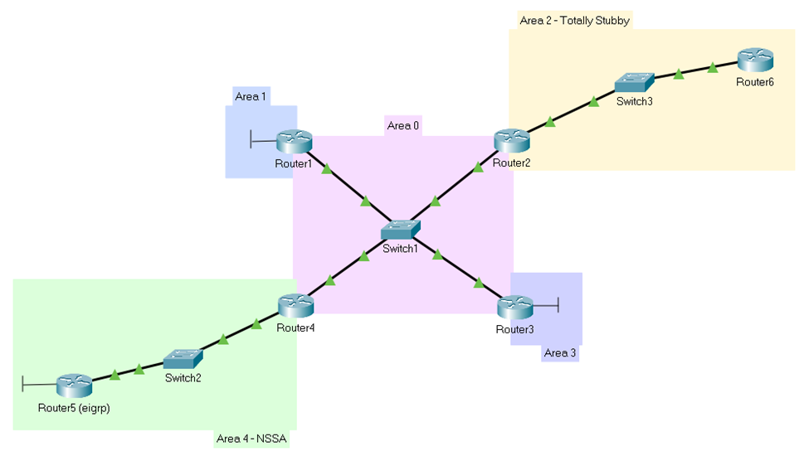

*Area 1 – Normal, Area 2 – Totally Stubby, Area 3 – Normal, Area 4 – Not So Stubby

|  |  |  |  |  |  |  |  |
| --- | --- | --- | --- | --- | --- | --- | --- |
|  | g0/0/0 | Area | g0/0/1 | Area | lo0 | Area | Router ID |
| R1 | 10.0.0.1/24 | 0 | N/A | N/A | 192.168.1.1/32 | 1 | 1.1.1.1 |
| R2 | 10.0.1.1/24 | 0 | 10.200.1.1/24 | 2 | N/A | N/A | 2.2.2.2 |
| R3 | 10.1.0.1/24 | 0 | N/A | 3 | 192.168.3.1/32 | 3 | 3.3.3.3 |
| R4 | 10.1.1.1/24 | 0 | 10.100.1.1/24 | 4 | N/A | N/A | 4.4.4.4 |
| R5 | N/A | N/A | 10.100.2.1/24 | 4 | 192.168.5.1/32 | N/A | 5.5.5.5 |
| R6 | N/A | N/A | 10.200.2.1/24 | 2 | N/A | N/A | 6.6.6.6 |

|  |  |  |  |  |
| --- | --- | --- | --- | --- |
|  | f1/0/1 | f1/0/3 | f1/0/5 | f1/0/7 |
| S1 (all area 0) | 10.0.0.2/24 | 10.0.1.2/24 | 10.1.0.2/24 | 10.1.1.2/24 |
| S2 (all area 2) | 10.100.1.2/24 | 10.100.2.2/24 | N/A | N/A |
| S3 (all area 4) | 10.200.1.2/24 | 10.200.2.2/24 | N/A | N/A |

**Configurations** – show run/Wireshark captures

**Router 1**

show run

Current configuration : 1781 bytes

! Last configuration change at 16:53:23 UTC Mon Oct 9 2023

version 16.7

service timestamps debug datetime msec

service timestamps log datetime msec

platform qfp utilization monitor load 80

no platform punt-keepalive disable-kernel-core

hostname R1

boot-start-marker

boot-end-marker

vrf definition Mgmt-intf

address-family ipv4

exit-address-family

address-family ipv6

exit-address-family

no aaa new-model

subscriber templating

vtp domain cisco

vtp mode transparent

multilink bundle-name authenticated

license udi pid ISR4321/K9 sn FDO220523GF

license boot level appxk9

no license smart enable

diagnostic bootup level minimal

spanning-tree extend system-id

redundancy

mode none

interface Loopback0

ip address 192.168.1.1 255.255.255.255

ip ospf 1 area 1

interface GigabitEthernet0/0/0

ip address 10.0.0.1 255.255.255.0

ip ospf 1 area 0

negotiation auto

interface GigabitEthernet0/0/1

no ip address

shutdown

negotiation auto

interface Serial0/1/0

no ip address

shutdown

interface Serial0/1/1

no ip address

shutdown

interface GigabitEthernet0/2/0

no ip address

shutdown

negotiation auto

interface GigabitEthernet0/2/1

no ip address

shutdown

negotiation auto

interface GigabitEthernet0

vrf forwarding Mgmt-intf

no ip address

shutdown

negotiation auto

router ospf 1

router-id 1.1.1.1

ip forward-protocol nd

ip http server

ip http authentication local

ip http secure-server

ip tftp source-interface GigabitEthernet0

control-plane

line con 0

transport input none

stopbits 1

line aux 0

stopbits 1

line vty 0 4

login

wsma agent exec

wsma agent config

wsma agent filesys

wsma agent notify

end

**Router 2**

show run

Current configuration : 3899 bytes

! Last configuration change at 16:36:55 UTC Mon Oct 9 2023

version 16.9

service timestamps debug datetime msec

service timestamps log datetime msec

platform qfp utilization monitor load 80

platform punt-keepalive disable-kernel-core

hostname R2

boot-start-marker

boot-end-marker

vrf definition Mgmt-intf

address-family ipv4

exit-address-family

address-family ipv6

exit-address-family

no aaa new-model

login on-success log

subscriber templating

vtp domain cisco

vtp mode transparent

multilink bundle-name authenticated

crypto pki trustpoint TP-self-signed-2189345785

enrollment selfsigned

subject-name cn=IOS-Self-Signed-Certificate-2189345785

revocation-check none

rsakeypair TP-self-signed-2189345785

license udi pid ISR4321/K9 sn FDO21482DXE

license boot level appxk9

no license smart enable

diagnostic bootup level minimal

spanning-tree extend system-id

redundancy

mode none

interface GigabitEthernet0/0/0

ip address 10.0.1.1 255.255.255.0

ip ospf 1 area 0

negotiation auto

interface GigabitEthernet0/0/1

ip address 10.200.1.1 255.255.255.0

ip ospf 1 area 2

negotiation auto

interface Serial0/1/0

no ip address

shutdown

interface Serial0/1/1

no ip address

shutdown

interface GigabitEthernet0/2/0

no ip address

shutdown

negotiation auto

interface GigabitEthernet0/2/1

no ip address

shutdown

negotiation auto

interface GigabitEthernet0

vrf forwarding Mgmt-intf

no ip address

shutdown

negotiation auto

router ospf 1

router-id 2.2.2.2

area 2 stub no-summary

ip forward-protocol nd

ip http server

ip http authentication local

ip http secure-server

ip tftp source-interface GigabitEthernet0

control-plane

line con 0

transport input none

stopbits 1

line aux 0

stopbits 1

line vty 0 4

login

end

**Router 3**

show run

Current configuration : 3925 bytes

! Last configuration change at 16:30:37 UTC Mon Oct 9 2023

version 16.9

service timestamps debug datetime msec

service timestamps log datetime msec

platform qfp utilization monitor load 80

platform punt-keepalive disable-kernel-core

hostname R3

boot-start-marker

boot-end-marker

vrf definition Mgmt-intf

address-family ipv4

exit-address-family

address-family ipv6

exit-address-family

no aaa new-model

login on-success log

subscriber templating

vtp domain cisco

vtp mode transparent

multilink bundle-name authenticated

crypto pki trustpoint TP-self-signed-2557841031

enrollment selfsigned

subject-name cn=IOS-Self-Signed-Certificate-2557841031

revocation-check none

rsakeypair TP-self-signed-2557841031

license udi pid ISR4321/K9 sn FDO21500G1N

license boot level appxk9

no license smart enable

diagnostic bootup level minimal

spanning-tree extend system-id

redundancy

mode none

interface Loopback0

ip address 192.168.3.1 255.255.255.255

ip ospf 1 area 3

interface GigabitEthernet0/0/0

ip address 10.1.0.1 255.255.255.0

ip ospf 1 area 0

negotiation auto

interface GigabitEthernet0/0/1

no ip address

shutdown

negotiation auto

interface Serial0/1/0

no ip address

shutdown

interface Serial0/1/1

no ip address

shutdown

interface GigabitEthernet0/2/0

no ip address

shutdown

negotiation auto

interface GigabitEthernet0/2/1

no ip address

shutdown

negotiation auto

interface GigabitEthernet0

vrf forwarding Mgmt-intf

no ip address

shutdown

negotiation auto

router ospf 1

router-id 3.3.3.3

ip forward-protocol nd

ip http server

ip http authentication local

ip http secure-server

ip tftp source-interface GigabitEthernet0

control-plane

line con 0

transport input none

stopbits 1

line aux 0

stopbits 1

line vty 0 4

login

end

**Router 4**

show run

Current configuration : 3691 bytes

! Last configuration change at 16:18:57 UTC Mon Oct 16 2023

version 16.9

service config

service timestamps debug datetime msec

service timestamps log datetime msec

platform qfp utilization monitor load 80

platform punt-keepalive disable-kernel-core

hostname R4

boot-start-marker

boot-end-marker

vrf definition Mgmt-intf

address-family ipv4

exit-address-family

address-family ipv6

exit-address-family

no aaa new-model

login on-success log

subscriber templating

vtp domain cisco

vtp mode transparent

multilink bundle-name authenticated

crypto pki trustpoint TP-self-signed-1457377718

enrollment selfsigned

subject-name cn=IOS-Self-Signed-Certificate-1457377718

revocation-check none

rsakeypair TP-self-signed-1457377718

crypto pki certificate chain TP-self-signed-1457377718

license udi pid ISR4321/K9 sn FDO21441WDF

no license smart enable

diagnostic bootup level minimal

spanning-tree extend system-id

redundancy

mode none

interface GigabitEthernet0/0/0

ip address 10.1.1.1 255.255.255.0

ip ospf 1 area 0

negotiation auto

interface GigabitEthernet0/0/1

ip address 10.100.1.1 255.255.255.0

ip ospf 1 area 4

negotiation auto

interface Serial0/1/0

no ip address

interface Serial0/1/1

no ip address

interface GigabitEthernet0

vrf forwarding Mgmt-intf

no ip address

negotiation auto

router ospf 1

router-id 4.4.4.4

area 4 nssa

ip forward-protocol nd

ip http server

ip http authentication local

ip http secure-server

ip http client source-interface GigabitEthernet0/0/1

control-plane

line con 0

exec-timeout 0 0

transport input none

stopbits 1

line aux 0

stopbits 1

line vty 0 4

login

end

**Router 5**

Show run:

Current configuration : 1451 bytes

! Last configuration change at 16:53:39 UTC Mon Oct 9 2023

version 16.9

service timestamps debug datetime msec

service timestamps log datetime msec

platform qfp utilization monitor load 80

platform punt-keepalive disable-kernel-core

hostname R5

boot-start-marker

boot-end-marker

vrf definition Mgmt-intf

address-family ipv4

exit-address-family

address-family ipv6

exit-address-family

no aaa new-model

login on-success log

subscriber templating

multilink bundle-name authenticated

license udi pid ISR4321/K9 sn FDO215009QY

no license smart enable

diagnostic bootup level minimal

spanning-tree extend system-id

redundancy

mode none

interface Loopback0

ip address 192.168.5.1 255.255.255.255

interface GigabitEthernet0/0/0

no ip address

negotiation auto

interface GigabitEthernet0/0/1

ip address 10.100.2.1 255.255.255.0

ip ospf 1 area 4

negotiation auto

interface Serial0/1/0

no ip address

interface Serial0/1/1

no ip address

interface GigabitEthernet0

vrf forwarding Mgmt-intf

no ip address

negotiation auto

router eigrp 1

network 192.168.5.0 0.0.0.0

router ospf 1

router-id 5.5.5.5

area 4 nssa

ip forward-protocol nd

no ip http server

ip http secure-server

ip tftp source-interface GigabitEthernet0

control-plane

line con 0

transport input none

stopbits 1

line aux 0

stopbits 1

line vty 0 4

login

end

**Router 6**

Show run:

Current configuration : 3633 bytes

! Last configuration change at 16:26:50 UTC Mon Oct 9 2023

version 16.9

service timestamps debug datetime msec

service timestamps log datetime msec

platform qfp utilization monitor load 80

platform punt-keepalive disable-kernel-core

hostname R6

boot-start-marker

boot-end-marker

vrf definition Mgmt-intf

address-family ipv4

exit-address-family

address-family ipv6

exit-address-family

no aaa new-model

login on-success log

subscriber templating

vtp domain cisco

vtp mode transparent

multilink bundle-name authenticated

crypto pki trustpoint TP-self-signed-318861592

enrollment selfsigned

subject-name cn=IOS-Self-Signed-Certificate-318861592

revocation-check none

rsakeypair TP-self-signed-318861592

crypto pki certificate chain TP-self-signed-318861592

certificate self-signed 01

license udi pid ISR4321/K9 sn FDO214420HM

no license smart enable

diagnostic bootup level minimal

spanning-tree extend system-id

redundancy

mode none

interface GigabitEthernet0/0/0

no ip address

shutdown

negotiation auto

interface GigabitEthernet0/0/1

ip address 10.200.2.1 255.255.255.0

negotiation auto

interface Serial0/1/0

no ip address

shutdown

interface Serial0/1/1

no ip address

shutdown

interface GigabitEthernet0

vrf forwarding Mgmt-intf

no ip address

shutdown

negotiation auto

router ospf 1

router-id 6.6.6.6

area 2 stub no-summary

ip forward-protocol nd

ip http server

ip http authentication local

ip http secure-server

ip tftp source-interface GigabitEthernet0/0/0

control-plane

line con 0

transport input none

stopbits 1

line aux 0

stopbits 1

line vty 0 4

login

end

**Switch 1**

Show run:

Current configuration : 1835 bytes

version 12.2

no service pad

service timestamps debug datetime msec

service timestamps log datetime msec

no service password-encryption

hostname S1

boot-start-marker

boot-end-marker

no aaa new-model

system mtu routing 1500

vtp domain cisco

vtp mode transparent

authentication mac-move permit

ip subnet-zero

spanning-tree mode pvst

spanning-tree etherchannel guard misconfig

spanning-tree extend system-id

vlan internal allocation policy ascending

vlan 10

name Data

vlan 20

name Voice

interface FastEthernet0/1

no switchport

ip address 10.0.0.2 255.255.255.0

interface FastEthernet0/2

interface FastEthernet0/3

no switchport

ip address 10.0.1.2 255.255.255.0

interface FastEthernet0/4

interface FastEthernet0/5

no switchport

ip address 10.1.0.2 255.255.255.0

interface FastEthernet0/6

interface FastEthernet0/7

no switchport

ip address 10.1.1.2 255.255.255.0

interface FastEthernet0/8

interface FastEthernet0/9

interface Vlan1

no ip address

shutdown

router ospf 1

log-adjacency-changes

network 10.0.0.0 0.0.0.255 area 0

network 10.0.1.0 0.0.0.255 area 0

network 10.1.0.0 0.0.0.255 area 0

network 10.1.1.0 0.0.0.255 area 0

ip classless

ip http server

ip http secure-server

ip sla enable reaction-alerts

line con 0

line vty 5 15

monitor session 1 source interface Fa1/0/1 , Fa1/0/3, Fa1/0/5, Fa1/0/7

monitor session 1 destination interface Fa1/0/9

end

**Switch 2**

Show run:

Current configuration : 2580 bytes

! Last configuration change at 01:46:42 UTC Mon Mar 1 1993

version 12.2

no service pad

service timestamps debug datetime msec

service timestamps log datetime msec

no service password-encryption

hostname S2

boot-start-marker

boot-end-marker

no aaa new-model

system mtu routing 1500

ip routing

vtp domain BUSD

vtp mode transparent

spanning-tree mode pvst

spanning-tree extend system-id

interface FastEthernet1/0/1

no switchport

ip address 10.100.1.2 255.255.255.0

interface FastEthernet1/0/2

interface FastEthernet1/0/3

no switchport

ip address 10.100.2.2 255.255.255.0

interface Vlan1

ip address dhcp

router ospf 1

area 4 nssa

network 10.1.1.0 0.0.0.255 area 0

network 10.100.1.0 0.0.0.255 area 4

network 10.100.2.0 0.0.0.255 area 4

ip http server

ip http secure-server

logging esm config

line con 0

line vty 5 15

monitor session 1 source interface Fa1/0/1 , Fa1/0/3

monitor session 1 destination interface Fa1/0/5

end

**Switch 3**

Show run:

! Last configuration change at 01:15:46 UTC Mon Mar 1 1993

version 12.2

no service pad

service timestamps debug datetime msec

service timestamps log datetime msec

no service password-encryption

hostname S3

boot-start-marker

boot-end-marker

no aaa new-model

system mtu routing 1500

ip routing

vtp domain CCNP

vtp mode transparent

spanning-tree mode pvst

spanning-tree extend system-id

interface FastEthernet1/0/1

no switchport

ip address 10.200.1.2 255.255.255.0

interface FastEthernet1/0/2

interface FastEthernet1/0/3

no switchport

ip address 10.200.2.2 255.255.255.0

interface FastEthernet1/0/4

router ospf 1

area 2 stub no-summary

network 10.0.1.0 0.0.0.255 area 0

network 10.200.1.0 0.0.0.255 area 2

network 10.200.2.0 0.0.0.255 area 2

ip http server

ip http secure-server

logging esm config

line con 0

line vty 0 4

login

line vty 5 15

login

monitor session 1 source interface Fa1/0/1

monitor session 1 destination interface Fa1/0/5

end

**Wireshark captures**

Type 1 LSA

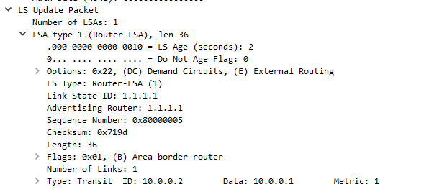

Type 2 LSA

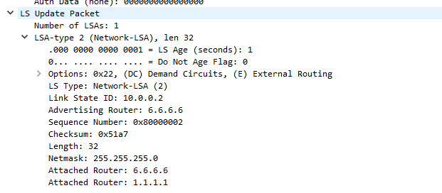

Normal Type 3 LSA & Totally Stubby Type 3 LSA

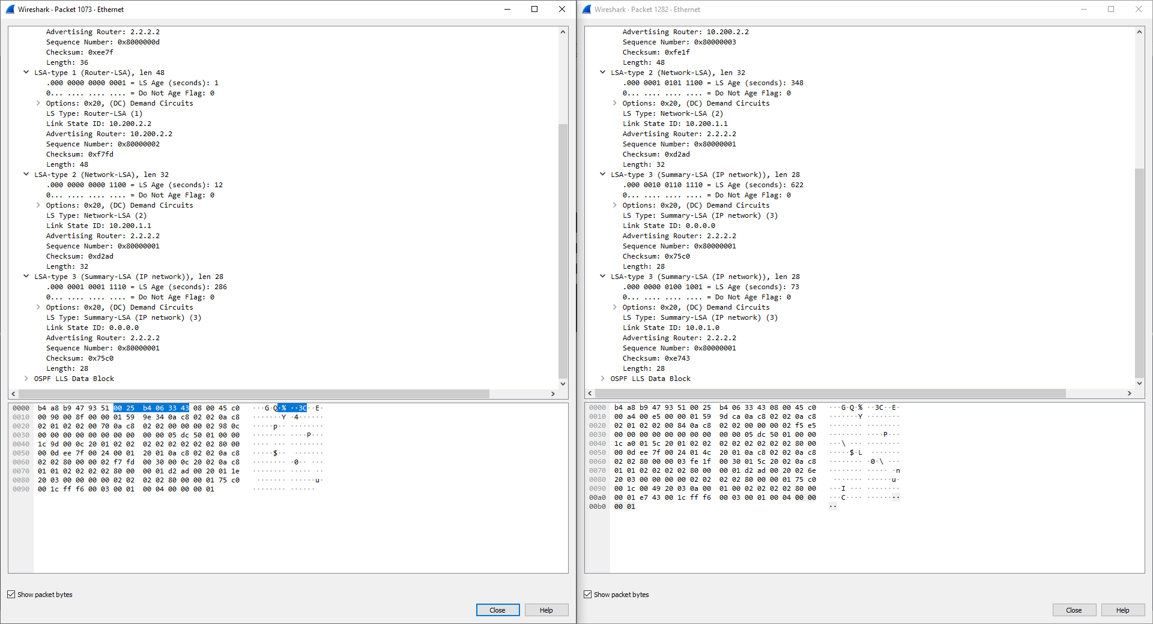

Type 4 LSA

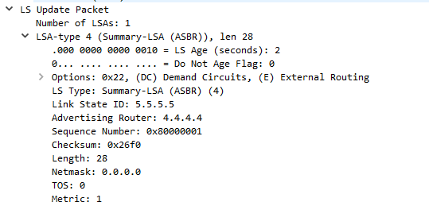

Type 5 LSA

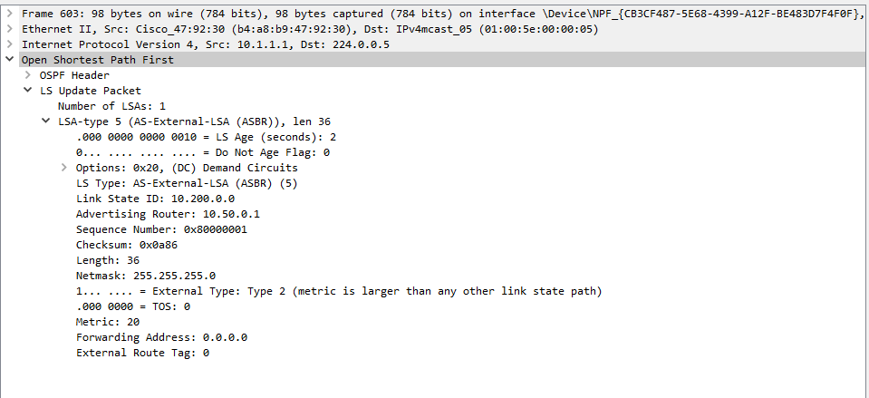

Type 7 LSA

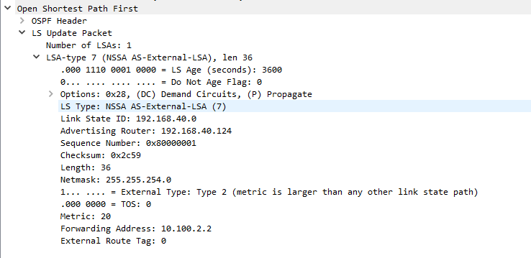

**Problems**

When we first set up the topology, all the routers were directly connected to one another through their g0/0/0 and g0/0/1 interfaces. We realized that this led for there to not be a way that we could capture routing packets. We fixed this problem by connecting all routers in each area to a central switch, which meant that we could connect our end devices (PCs_ to those switch interfaces to read the routing traffic.

When we connected our routers to the switch, we couldn’t ping any of our routers to ping through the switch in area 0. We found that this was because we didn’t have any initial configuration of the switch. We resolved this problem by making sure we configure all the interfaces on the switch as routing ports and all the separate networks route through OSPF. This also resulted n being how we connected the other two sets of routers to another.

When we started checking our traffic through Wireshark, we were unable to capture OSPF updates and description packets that contained information about LSAs and its types. We were only able to get hello packets coming through. To resolve this problem, we put the **“session-monitor”** command to use and captured all traffic from the ports. To make sure that these packets continued to come through, we use the **“clear ip ospf process”** command to restart OSPF to force description packets to appear in Wireshark.

When Stubby or Not So Stubby areas were configured, we ran into inconsistency issues between routers and the areas’ connection. We simply decided to make sure that the stubby areas were configured on *both* devices on the link and this issue was fixed.

Type 5 and Type7 LSAs that came from external networks of the OSPF were a particular challenge for out group. This was because the routes dd not distribute into the OSPF network readily. To resolve this, we use the command **“redistribute routes”** in the OSPF of the routers to force them to send.

**Conclusion**

This lab demonstrates my group and I successfully being able to configure multi-area OSPF and OSPFv3 using 5 routers and 3 areas. From creating a topology from scratch with an IP scheme to configuring it on a physical rack, we were able to utilize our skills we learned from out CCNA course and our first lab. Along with those skills, we analyzed our problems and troubleshooted these issues and documented all of the process and results. Through the completion of this lab, we had issues with OSPFv3 configuration and connectivity between R3, R4, and R5. With this, we were able to learn how to determine when a multi-area OSPF network is operational in a routing table and pick up some methods to keep in mind that *don’t work* when handling OSPF routing issues.

